Lesson Six (Teacher)
“The Greenhouse Effect and Climate Change”

(Note to Teachers: The greenhouse effect is considered an 8th grade topic in Texas. For 5th grade classrooms, you may consider omitting or simplifying Step 2 of the lesson plan.)
Objective
By now, students have learned how minute quantities of air pollutants in the atmosphere can affect their health. Today they will learn how small amounts of certain gases can also affect the planet’s climate. Students will learn how greenhouse gases like carbon dioxide keep the Earth at a livable temperature, and how increasing amounts of these gases may cause the climate to change. Students will compute their carbon footprint and discuss alternative sources of energy. Students should come away with a sense of their own impact on the environment and what they can do to reduce the creation of more emissions.
Background Information
The greenhouse effect is the warming of the Earth caused by certain gases in the atmosphere. The Figures on the next page show how this works. First, sunlight shines onto the Earth’s surface. The Earth absorbs some of this solar energy and radiates its own heat energy back toward space. Greenhouse gases are chemicals in the atmosphere that prevent some of the Earth’s heat from escaping into space, while letting sunlight pass through. Greenhouse gases include water vapor, carbon dioxide, methane, and chlorofluorocarbons.
The greenhouse effect is very beneficial to life on Earth because it warms the planet and moderates temperature extremes. Without greenhouse gases, the surface of the Earth would be too cold for liquid water! (For an interactive animation of the greenhouse effect, visit http://environment.nationalgeographic.com/environment/global-warming/gw-overview-interactive.html )
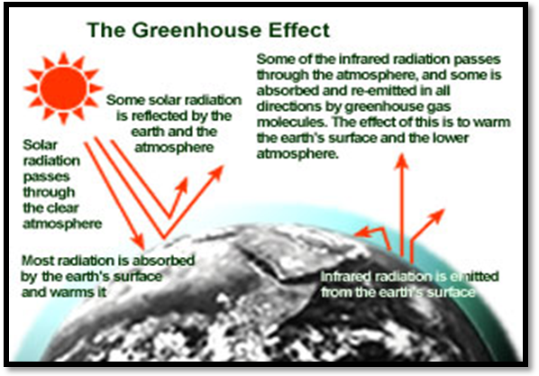

Greenhouse effect
Credit: http://www.epa.gov/climatechange/kids/greenhouse.html

While the greenhouse effect is necessary for most life on Earth, increasing levels of greenhouse gases can cause Earth’s temperature to rise. This is what scientists believe is currently happening to our planet. The burning of fossil fuels and the loss of forests have caused levels of greenhouse gases like carbon dioxide to increase significantly over the past century. Many greenhouse gases remain in the atmosphere for decades. As a result, more and more heat is being trapped in the Earth’s atmosphere, which is causing the Earth’s climate to warm.
Global warming is the increase in the average air temperature of Earth. Most climate scientists believe that the Earth’s average temperature has been rising over the past century, and that most of this warming has been caused by manmade emissions of greenhouse gases, such as the burning of fossil fuels.
Global warming can make it difficult for humans and natural ecosystems to adapt, especially if temperatures rise rapidly. Warm temperatures can melt major ice sheets and cause ocean water to expand, which could cause sea levels to rise significantly. Weather patterns could shift and become more extreme, with severe floods in some region and severe droughts in others. According to the Intergovernmental Panel on Climate Change, 11 of the 12 hottest years since thermometer reading became available occurred between 1995 and 2006!
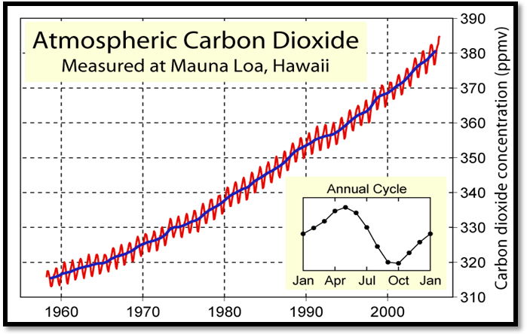
Atmospheric carbon dioxide concentrations have been increasing in recent decades.
Credit: http://www.globalwarmingart.com/wiki/Image:Mauna_Loa_Carbon_Dioxide_png
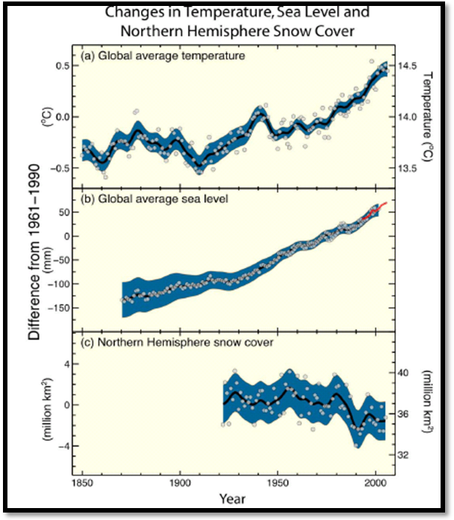
Global temperatures and sea levels have been rising.
Credit: Intergovernmental Panel on Climate Change

So what can we do to prevent global warming? Burning of fossil fuels (coal, oil, and natural gas) is the biggest source of greenhouse gases. Fossil fuel use can be reduced by energy efficiency and conservation, and by switching to alternative sources of energy such as wind, solar, or nuclear power.
One way to calculate your impact on the environment and contribution to the heating of the earth is the “Carbon footprint.” A carbon footprint tells you how much carbon dioxide is emitted as a result of your day-to-day lifestyle and actions. It can also tell you what actions could reduce the amount of pollutants are released into the air. Toward the end of this lesson, students will compute their own carbon footprints using an EPA computer program online.

How can we keep our air clean and reduce our carbon footprint?
- Walk, bike or take the bus
- Look out for energy-efficient appliances and light bulbs
- Ask your parents to make sure that the air conditioner is in good condition
- Shut off the lights when you are not in the room, and turn off your electronic appliances when they are not in use.
- Save water! Turn off the water when it is not in use, and only do the laundry or run the dishwasher with a full load of clothes or dishes.
- Set the thermostat so that your heater or air conditioner run less while you are away.
Additional reading materials:
    - Greenhouse Effect
http://www.epa.gov/region01/students/pdfs/greenhouse.pdf
http://www.windows.ucar.edu/tour/link=/earth/interior/greenhouse_effect.html
    - Causes and Effects of Global Warming
http://environment.nationalgeographic.com/environment/global-warming/gw-causes.html
http://environment.nationalgeographic.com/environment/global-warming/gw-effects.html
    - Clean Fuels
http://www.epa.gov/region01/students/pdfs/rd_clean.pdf
Materials (for a class of 25)

- Hygrometer (1 per class)
- Infrared Thermometer (1 per class)
- Ozone Test Strips (1 per class)
- Ozone Scanner (1 per class)
- Wind Vane (1 per class)
- Thermal Glove (1 per class)
- Cloud Charts (1 per class)
- GLOBE Measurement Data Sheets (1 per student)
- Computers
- Projection Screen
- Access to Brainpop.com

Vocabulary

- Low-level ozone
- Greenhouse effect
- Global warming
- Atmosphere
- Carbon footprint
- Alternative fuels
- Alternative energy
- Greenhouse effect
- Greenhouse gases

Step 4 in Lesson Plan
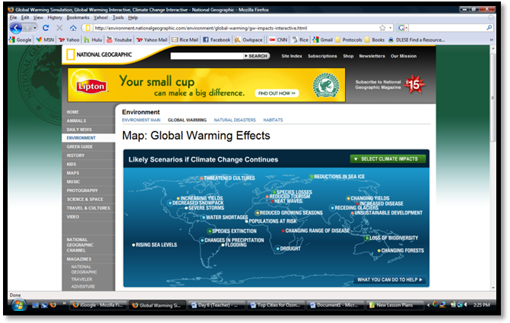
http://environment.nationalgeographic.com/environment/global-warming/gw-impacts-interactive.html
Step-by-Step Suggested Lesson Plan
Instructor Activity  - Measurements. Take your students outside and conduct the GLOBE protocols. Students should set up the ozone strip, take the air and surface temperature, observe the sky for clouds, and measure humidity and wind direction.  - (Optional: Above 5th grade learning objectives). Ask students to brainstorm examples of something in balance, such as a budget. Explain that Earth maintains a balance between solar energy absorbed from the Sun and heat energy that Earth sends back to space. Greenhouse gases trap in some of Earth’s heat energy and make the planet warmer. Draw a picture like the one on p. 2 to illustrate this. Make it clear that the greenhouse effect is good for Earth to some extent, but that increasing amounts of greenhouse gases can change the climate. Optional video: “Greenhouse effect” on Brainpop.com  - Ask students how scientists could measure if climate is changing. Discuss some of the evidence that the climate is warming, such as rising CO₂ levels, temperatures, and sea level (see p. 3).  - Online Activity. Next, guide students to an interactive map of global warming impacts at: http://environment.nationalgeographic.com/environment/global-warming/gw-impacts-interactive.html. Guide students to answer related questions in journals.  - Online Activity. Guide students to compute their carbon footprint at: http://www.epa.gov/climatechange/kids/calc/index.html. This carbon footprint calculator helps students discover how much carbon emissions result from their actions, and how much those emissions can be reduced by simple changes. Ask students what actions they think are most doable for reducing their carbon footprint.  - Take your class outside, and scan the ozone strip. Also, retake the surface and air temperature and humidity so that students can take the average of these measurements to supplement their ozone measurements. | Student Activity  Students take measurements and write down results on data sheets.  Students brainstorm examples, participate in discussion, and watch video.  Students discuss measurements that could indicate a changing climate.  Students visit website to explore some of the impacts of global warming worldwide, and answer related questions in their journal. (p. 2)  Students compute carbon footprint and answer related questions in journal (p. 3)  Students take measurements and write down their results on their data sheets.

Expected Outcomes
- Students understand the causes and effects of the greenhouse effect.
- Students understand the causes and effects of global warming.
- Students compute their carbon footprint and brainstorm ways to reduce carbon emissions.

